DC POWER SUPPLY

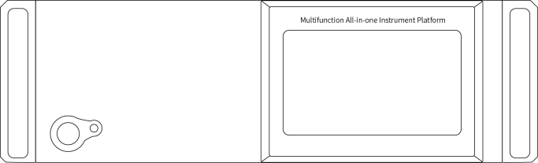

UMM-6 channel module power supply series product manual
Catalogue
Security Summary 1
Chapter Ⅰ Overview 2
1.1 Functional features 2
1.2 Front and back panels 2
1.2.1 Front Panel 2
1.2.2 Back Panel 7
Chapter Ⅱ Performance index 8
2.1 Voltage and current output 8
2.2 Display resolution 8
2.3 Preset accuracy of voltage and current 8
2.4 Stability 8
2.5 Operating Environment 8
2.6 Storage environment 8
2.7 Power Input 9
2.8 Accessories 9
2.9 Product size and weight 9
Chapter Ⅲ Product Toxic and Harmful Substances Statement 10
Chapter Ⅳ Warranty Service 12

Security Summary
This chapter contains important safety instructions that must be followed to operate, store, and clean the power supply. To ensure your personal safety, please read the operating instructions before operating.

Safety Guide
General Introduction  | - Do not place heavy objects on the case.
 | - Avoid damage to the machine due to severe impact or improper handling.
 | - Take precautions against electrostatic discharge when connecting the instrument.
 | - Do not block or isolate the fan vents.
 | - Do not open the machine unless it is a professional.
Power Supply  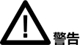 | - Input voltage: AC 220±10%,50Hz (or customized 110V ± 10%,60Hz)
 | - The ground wire of the power cord needs to be connected to the ground terminal to avoid electric shock.
Cleaning the machine | - Cut off the power before cleaning.
Cleaning the machine | - Use mild detergent and water to wet a soft cloth, do not spray detergent directly.
Cleaning the machine | - Do not use chemicals or cleaning agents containing abrasive products such as benzene, toluene, xylene and acetone.
Operating Environment | - Place of use: indoor, avoid direct sun, dust and strong magnetic field.
Operating Environment | - Relative humidity:<80%
Operating Environment | - Altitude:<2000m
Operating Environment | - Temperature: 5 ℃ to 40 ℃
Storage Environment | - Location: Indoor
Storage Environment | - Relative humidity:<70%
Storage Environment | - Temperature:-20 ℃ to 80 ℃

Chapter Ⅰ Overview
This series of products is the integrated 3~6 groups of power modules programmable DC power supply, equipped with a 7-inch touch screen as a display window, the operation is more simple, more intuitive and clear parameter display.

  - Functional features
- Maximum support 6 output channels, can be independent or synchronous output;
- 7-inch touch screen, simple and convenient operation, intuitive and clear display;
- The output constant voltage and constant current modes are automatically switched according to the load;
- Over voltage, over current, over power, over temperature, short circuit five powerful protection function;
- Support MODBUS RTU protocol, standard USB, RS232, RS485 three kinds of communication serial port;
- Equipped with line loss compensation, hardware compensation two compensation methods, can improve the output accuracy.

  - Front and back panels
    - Front Panel
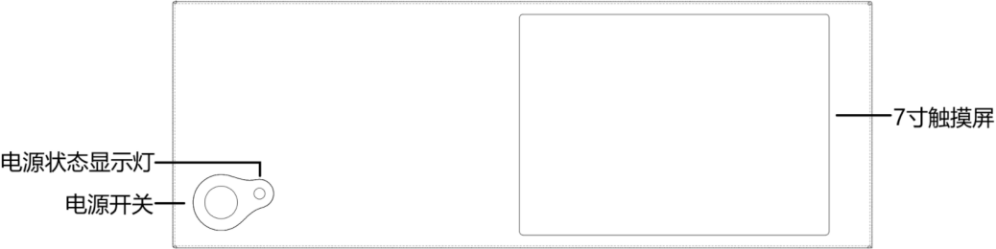
Touch screen
Power status
Indicators
Power switch
- Power switch: It is used to turn on or off the power, and the pressed state is on.
- Power status indicator: shows the power-on state, green indicates the power-on state, and off indicates the power-off state.
- Touch screen
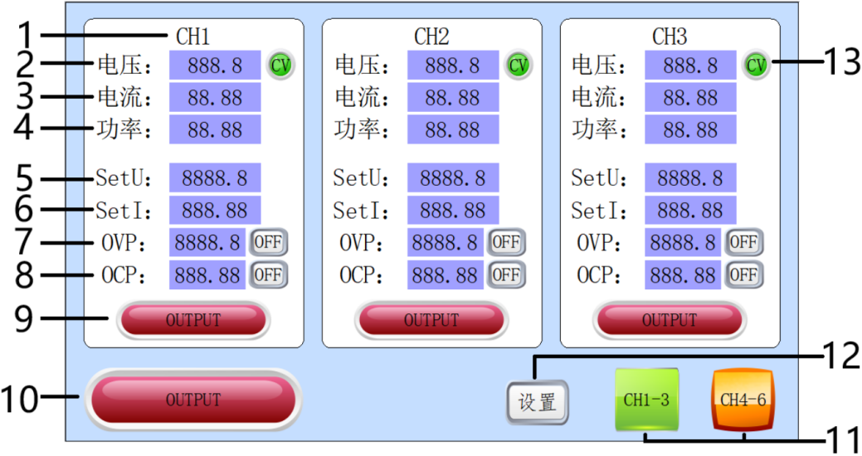
- Channel setting window: "CH1"-"CH6" channel setting window corresponds to the CH1-CH6 channel on the rear panel. Each setting window can edit the setting voltage (SetU), setting current (SetI), overvoltage protection (OVP), overcurrent protection (OCP) and output status (OUTPUT) of the corresponding channel.
- "Voltage": Output voltage value display window, unit: Volts (V).
- "Current": Output current value display window, unit: ampere (A).
- "Power": output power display window, unit: watts (W).
- "SetU": voltage setting window, unit: volt (V), click to enter the voltage setting parameter editing.
- "SetI": current setting window, unit: ampere (A), click to enter the current setting parameter editing.
- "OVP": overvoltage protection setting window, the value on the left is the overvoltage protection threshold, unit: volt (V), click the value to enter editing; the string on the right is the switch state of overvoltage protection, "ON" means to turn on the overvoltage protection, "OFF" means to turn off the overvoltage protection. When the output voltage is greater than the overvoltage threshold, the power supply immediately turns off the output.
- "OCP": Overcurrent protection setting window, the value on the left is the overcurrent protection threshold, unit: Abe (A), click the value to enter editing; The string on the right is the switch state of overcurrent protection, "ON" means to turn on overcurrent protection, and "OFF" means to turn off overcurrent protection. When the output current is greater than the overcurrent threshold, the power supply immediately turns off the output.
- Independent on-off switch: It can independently control the output state of the corresponding channel. Click to switch the output state. "OUTPUT" shows green to indicate that the output of the channel is on, and red to indicate that the on-output is off.
- On/off the main switch: can control the output state of all channels at the same time. "OUTPUT" is green, indicating that the output of at least one channel is on, and you can click to turn it on all at the same time; red indicates that the output of all channels is off.
- "CH1-3", "CH4-6": each 3 channel is a display interface, click to switch to a different channel interface.
- "Settings": this window can set the station number, baud rate, touch calibration, screen saver time, backlight brightness, setting interface is as follows:
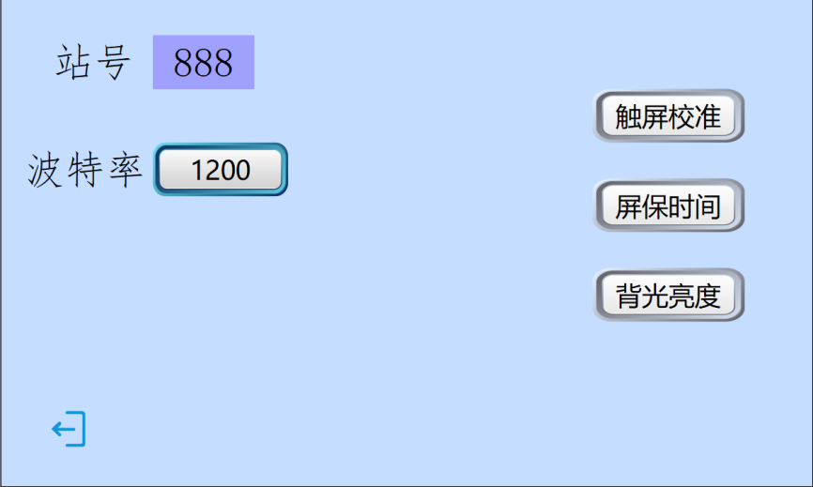
- "Station No.": the communication address of this machine.
- Baud Rate: Optional 1200, 2400, 4800, 9600, 19200, 38400, 57600, 115200.
- "Touch screen calibration": When the touch control click position is deviated, you can use this function to calibrate, click in the order of 1-5 to calibrate.
- "Screen saver time": pull the slider to set the screen saver time. when the time is 0s, the screen saver function will not be turned on. when the time is greater than 0s, the screen will be extinguished for the corresponding time.
- "Backlight Brightness": Pull the slider to change the backlight percentage, the larger the percentage, the stronger the brightness.
- Output mode: "CV" is a constant voltage output mode, and "CC" is a constant current output mode.

- "Configuration Parameters": This window can set the power-on output function, compensation mode, etc. The configuration parameters interface is as follows:
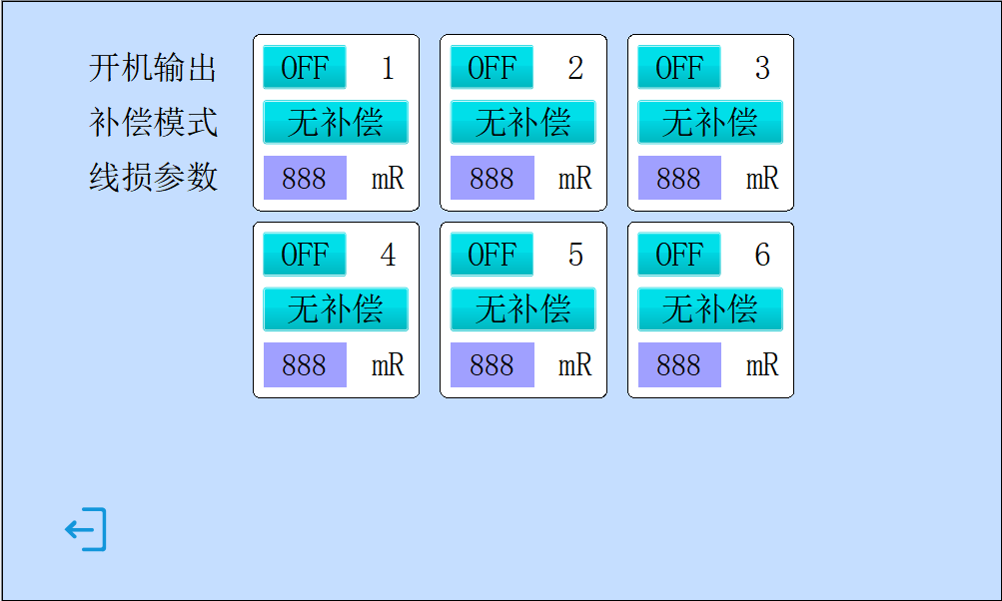
- "Power-on output": Select the output state after the power is turned on again. "OFF" indicates that the output is turned off after power-on, and "ON" indicates that the output is turned on after power-on.
- "Compensation mode": This mode is used to compensate the voltage drop caused by the line loss of the output line. The default value is No Compensation. Click to switch between hardware compensation and line loss compensation.
- Hardware compensation: The connection method is as follows.
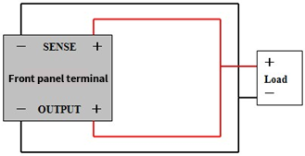
- Line loss compensation: By calculating the resistance value of the output line, the line loss parameter (mR) is input into the parameter window of the lower line loss compensation, and the output voltage of the power supply is increased to realize the voltage compensation function.
- Line Loss Parameter: This parameter is used in conjunction with line loss compensation.
- Prohibited: This window is a calibration window. The power supply has been calibrated before leaving the factory. In order to prevent wrong operation, the window is set to prohibit operation. If necessary, please contact the after-sales service.

    - Back Panel
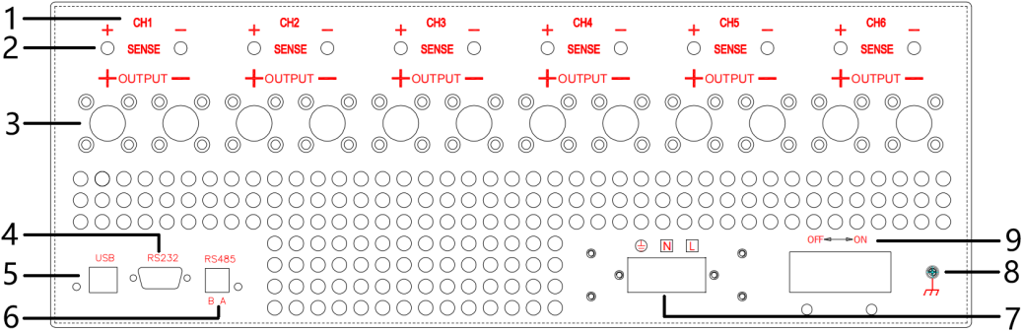
- Channel name: "CH1"-"CH6".
- Sense compensation: from left to right, corresponding to the compensation interface of each channel module, red is the compensation positive pole (+), black is the compensation negative pole (-). This function is optional.
- Output terminal: corresponding to the output terminal of each channel module from left to right, red is the output positive pole (+), black is the output negative pole (-).
- RS232 serial port: support RS485 serial communication.
- USB serial port: support USB serial communication.
- RS485 serial port seat: support RS485 serial port communication.
- Power input terminal: AC input, fire, zero, ground wire.
- Ground terminal: connected to the ground.
- Circuit breaker: power input overload will trip protection.

Chapter Ⅱ Performance index
When using this specification, please make sure to boot for more than 10 seconds.

  - Voltage and current output
Type | Output voltage | Output current | Output power
15V60A Module | 0V ~ 15V | 0A ~ 60A | 0~900W
20V50A module | 0V ~ 20V | 0A ~ 50A | 0~1000W
30V20A Module | 0V ~ 30V | 0A ~ 20A | 0~600W
30V30A Module | 0V ~ 30V | 0A ~ 30A | 0~900W
50V20A Module | 0V ~ 50V | 0A ~ 20A | 0~1000W
60V10A Module | 0V ~ 60V | 0A ~ 10A | 0~600W
60V15A Module | 0V ~ 60V | 0A ~ 15A | 0~900W
60V20A Module | 0V ~ 60V | 0A ~ 20A | 0~1200W
100V5A Module | 0V ~ 100V | 0A ~ 5A | 0~500W
100V10A module | 0V ~ 100V | 0A ~ 10A | 0~1000W

  - Display resolution
Voltage resolution | ＜100V：10mV  ≥100V：100mV
Current resolution | 10mA

  - Preset accuracy of voltage and current
Output Voltage Preset Accuracy | 0.1V
Output current preset accuracy | 0.1A

  - Stability
voltage stability | ≤±(0.2%+0.05V)
Current stability | ≤±(0.5%+0.05A)
Load stability | ≤0.5%
Ripple and noise | ≤1%（RMS）

  - Operating Environment
Elevation | ≤2000m
Relative humidity | ＜80%
Ambient temperature | 5℃~ 40℃

  - Storage environment
Ambient temperature | -20~80℃
Relative humidity | ≤80%

  - Power Input
Input | AC 220V ± 10%,50Hz (or AC 110V ± 10%,60Hz input)

  - Accessories
Accessory | Quantity
Instructions | 1
Certificate | 1
Power Cord | 1
USB cable | 1
RS485 Terminal | 1
RS232 serial line (23 female and female cross lines) | 1

  - Product size and weight
Dimensions | 500(D)×430(W)×155(H)mm
Weight | About 18.7kg

Chapter Ⅲ Product Toxic and Harmful Substances Statement
Components  Name | Toxic and harmful substances or elements in the product
Components  Name | Lead  (Pb) | Mercury  (Hg) | Cadmium  (Cd) | hexavalent chromium  (Cr(VI)) | Polybrominated Biphenyls  (PBB) | Polybrominated diphenyl ethers  (PBDE)
Printed Circuit Assembly | X | O | O | O | O | O
Transformer | X | O | O | O | O | O
Connection line | X | O | O | O | O | O
Hardware chassis | X | O | O | O | O | O
Power Cord | X | O | O | O | O | O
Electronic Materials | O | O | O | O | O | O
Plastic panel | O | O | O | O | O | O
Packaging Materials | O | O | O | O | O | O
O: The content of the toxic and hazardous substance in all homogeneous materials of the component is below the limit requirements specified in SJ/T11363-2006.
X: Indicates that the content of the toxic and hazardous substance in at least a certain 1 of the homogeneous material of the component exceeds the limit requirements specified in the SJ/T11363-2006 standard.
Note: This table shows that the product may contain these substances, but this information may be constantly updated with the development of technology. The reason marked with "X" is that there is no alternative technology and components available at this stage, and it meets the regulatory requirements of the the People's Republic of China "Administrative Measures for Pollution Control of Electronic Information Products.

Chapter Ⅳ Warranty Service
- Sincerely thank you for choosing this power supply, our company will strictly implement the national three guarantees policy. If it is not caused by human factors but belongs to the quality problem of the product itself, you can handle repair, exchange and return with invoices and three-pack vouchers. If the warranty period is exceeded, only the replacement of spare parts will be charged.
2. Please properly package and transport the products for repair. If there is any damage or loss during transportation, the company will not be responsible.
- The warranty card must be stamped and dated by the after-sales unit to ensure your rights and interests.
4. The following conditions do not belong to the scope of maintenance-free service:
(1) More than three packages of validity.
(2) altering the Three Guarantees voucher without authorization.
(3) not in accordance with the requirements of the product instructions for use, maintenance, storage and damage caused.
(4) Natural disasters, power grid failure or other irresistible factors cause damage to the product.
(5) Accessories are not covered by the warranty.
(6) The product model or number on the three-pack certificate does not match the physical product.

Warranty card

This card is the product warranty certificate, please be sure to keep it properly
Product name (product model)
Purchase Date
Sales Unit
Customer Name
Customer Address
Customer Phone
Fault Description
Note: Enjoy free warranty service (excluding accessories) within 12 months of warranty period, and who sends the freight (only for mainland customers)

